Day 7

Docker

How to containerization

how to deploy a container using CI/CD

integration the concept in the devops cycle

Would need proper difference on container and VM

If we want to run more than one container those container are running independently or they are communicating with each other to do some task.

1. Docker Compose
2. Docker swarm
3. Kubernetes

Docker swarm and Kubernetes are known as container management tools.

In Docker compose all container must be run in same machine or node or device.

But Docker swarm as well as Kubernetes all container can be run on same machine or different machine or node but those machine or nodes must be in same cluster environment.

We will run another docker compose file to run more than one container and those container are interacting with each other.

Frontend technologies backend technologies database

Html, css, js, ts, java or spring boot mysql or

Angular or react or or asp.net oracle

Any other JavaScript python or php or db2

Library node js with express js mongo db

Neo4j

Front container backend container database container

Login page Rest API language check with database.

Sign in or we will receive the

Singup send the information

Data from

To backend frontend

Technologies technologies

Os os os

Angular public spring boot Private mysql

Public : angular and spring boot

Private : spring boot and database

Frontend and backend technologies will communicate using http protocol.

OS OS

Frontend backend

<http://localhost:9090>

<http://IPAddress:9090>

to open mysql database container os

sudo docker exec -it mysql-container bash

after open mysql os

please connect to mysql database using command as

mysql -u root -p

password : root

show databases this command is use to display all databases names

use mydb; it is use to switch inside that database or move inside that database.

show tables; show all tables present in current database.

**Orchestration tool : it is responsible to manage the life of container. Scale up, Scale down, availability, health check, heal up, rollback, etc.**

Kubernetes also known as K8S.

Cluster : we need to connected more than one machine or node in one network environment.

Micro service

Add product and display the product

Login module Team1 java mysql

Dashboard module Team2 python

Product module Team3

Order module

Payment module .net or asp.net or node js mongo db

Feedback module Teamn

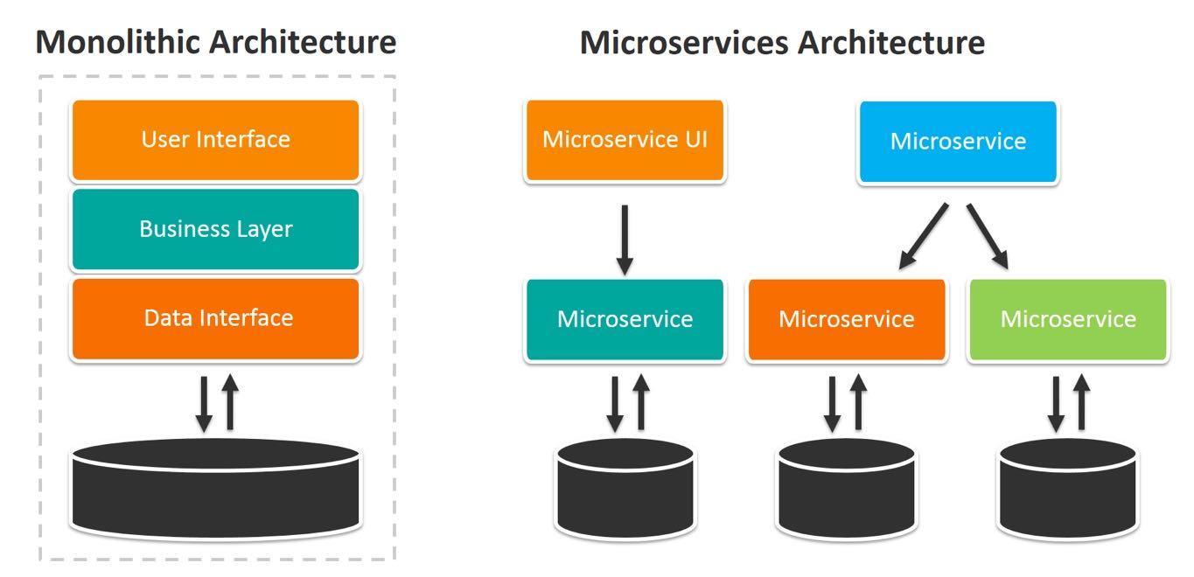

Kubernetes Cluster :

Cluster environment helps to run more than one container in same node or different nodes.

Node : it is a single host which is capable of running on physical or virtual machine with unique IP Address.

Cluster : it is a collection of host or serve or nodes or machine that helps you to aggregate the availability.

Kubernetes cluster:

Kubeadm : kubeadm is a tool provided by Kubernetes which help to provide Kubernetes cluster environment.

Kubeadmn provide master node as well as we can make more than one worker node.

Master node : it is responsible for managing Kubernetes cluster environments.

Worker node : we need to connect master node to do some operation in Kubernetes cluster environment.

Node EC2 instance to run master node

Then we can create more than one instance to connect master node. And to communicate to master node Kubernetes provided kubectl tools which help to deploy the container in Kubernetes cluster environments.

There are lot off other tools present in market which provide Kubernetes Cluster environment.

1. minikube : it is an open source tool which provide single cluster Kubernetes environments.

